**Using Tableau workbooks to generate graphs and maps from reports.**

**Overview**

This document specifies how to use a Tableau workbook to quickly generate campaign metrics (CTR, CTR, #impressions), maps and various graphs to help report generation. The workbooks are available [here](https://www.dropbox.com/home/Alphonso%20Campaign%20Reporting/Elle%20%26%20Gaelle). There are 3 different workbooks:

* Performance Report workbook: can be found [here](https://www.dropbox.com/home/Alphonso%20Campaign%20Reporting/Elle%20%26%20Gaelle?preview=PerformanceReportTableauWorkbook.twbx), it allows to generate graphs and performance metrics for a campaign from a Beeswax Performance report.
* Geography Report workbook: can be found [here](https://www.dropbox.com/home/Alphonso%20Campaign%20Reporting/Elle%20%26%20Gaelle?preview=Geo+Report+Workbook.twbx), allows to generate maps and view viewership and completion rate by DMA, city and state.
* Insights Report workbook: can be found [here](https://www.dropbox.com/home/Alphonso%20Campaign%20Reporting/Elle%20%26%20Gaelle?preview=Insights+Report+WorkBook.twbx), allows to generate graphs from an Alphonso Insight report.

This document will give the reader a brief overview of how to import a report generated on Beeswax or Alphonso Insights to a Tableau workbook and how to view the results.

The three workbooks are then explained further with a step-by-step description of the worksheets.

**1- Import data to a Tableau workbook**

Open one of the three packaged workbooks above.

Click on the tab **Data Source** (see screenshot below)

In the left pane, find the **Connections** section

Find “Geo Report”, “Performance Report” or “Airings Report”

Click on the downward arrow, then **edit connection**

Find your report (it has to be in csv format)

Click open

The data should automatically refresh and correspond to your report

**→ You have now imported your data to the Tableau workbook, all of the graphs contained in the sheets should correspond to your data.**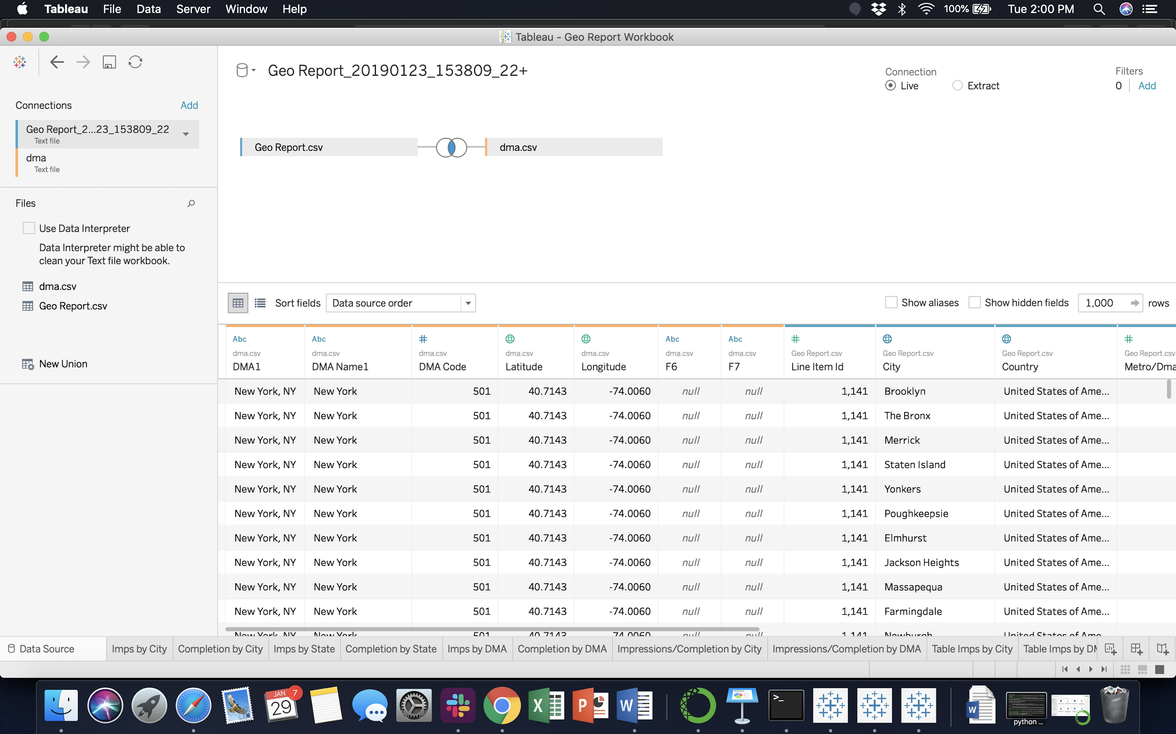

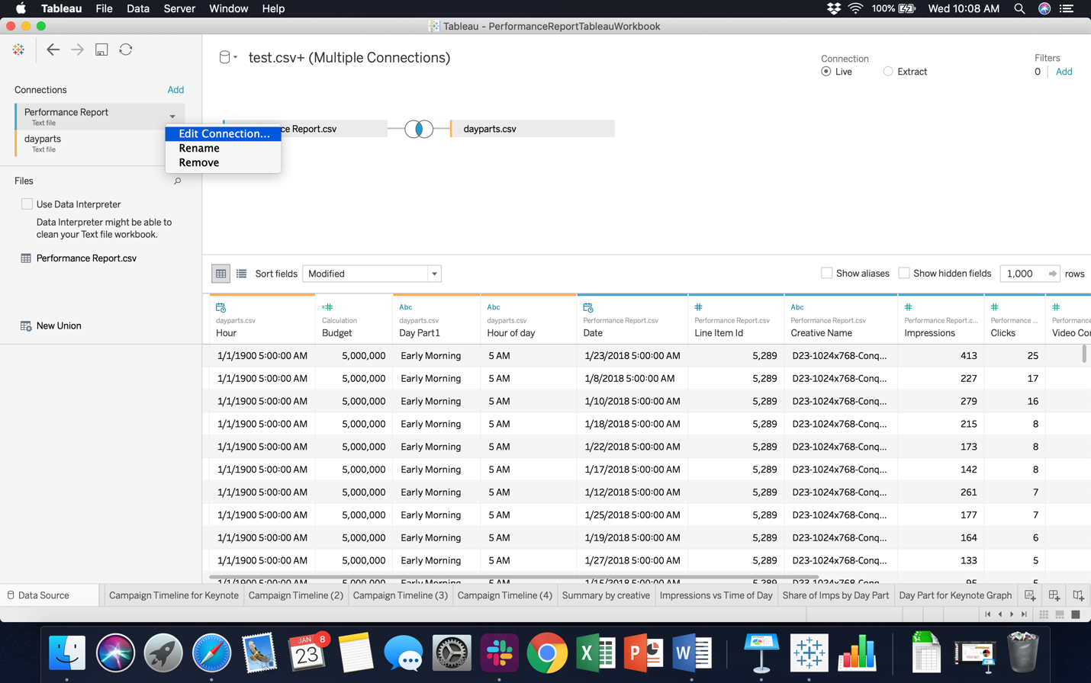

Figure 1 - Importing data to a Tableau Workbook

**2- Tableau Performance Report Workbook**

This workbook can be used to generate all of the graphs required in a Digital Campaign Performance Study. It computes campaign metrics (vcr, ctr, impressions) and also breaks down performance by Line Item, daypart, day and creative.

To generate the graphics, you will need:

* Your campaign name or ID
* Your campaign budget (from the deal sheet, in impressions or video completes)
* Access to Beeswax
* The Performance Report Workbook ([here](https://www.dropbox.com/home/Alphonso%20Campaign%20Reporting/Elle%20%26%20Gaelle?preview=PerformanceReportTableauWorkbook.twbx))

*Note: you may see that the workbook uses another spreadsheet entitled “Dayparts”. This spreadsheet is used to map each hour of the day to a specific daypart in order to generate analysis by DayPart.*

**Step 1: Generate a performance report for your campaign**

Log in to Beeswax ([here](https://alphonso.beeswax.com/login?u=%2Fadvertisers))

In the Reporting tab, go to the Query tool.

Fill in the following fields:

* Report type: Performance Report
* Fields:
  + Hour
  + Line item ID
  + Creative Name
  + Any other field you wish to work with
* Metrics
  + Clicks
  + Impressions
  + Video Completes
  + Any other metric you wish to view
* Select your campaign in Campaign Name or Campaign ID field
* Format: CSV

Run and Download the report in csv format

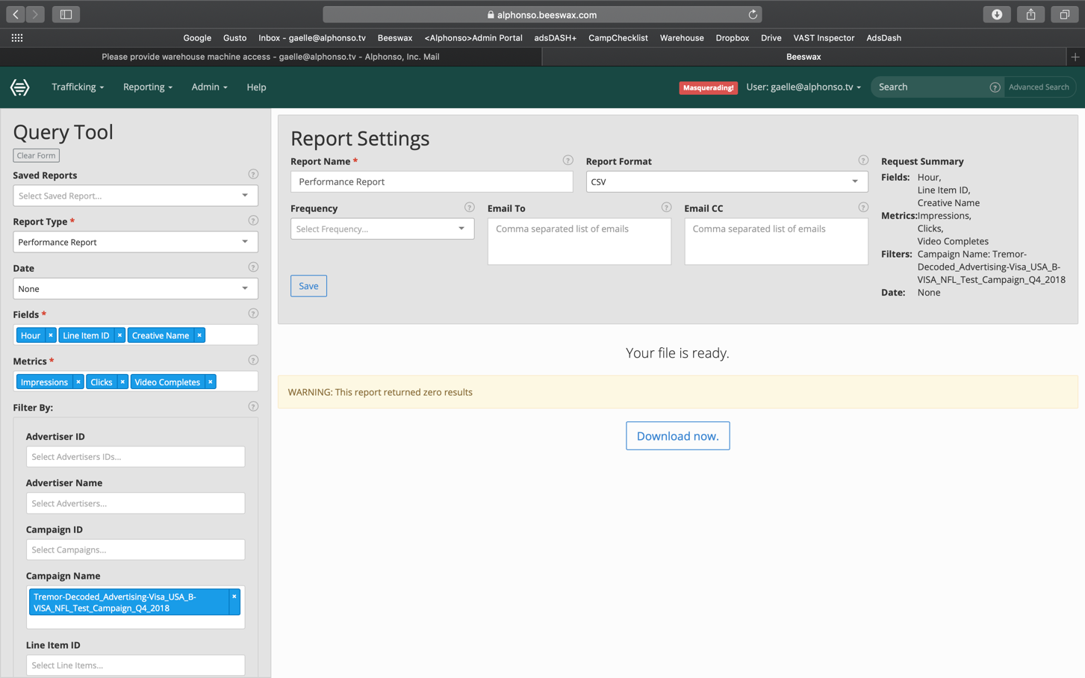

Figure 2 – Beeswax Query Tool Interface

**Step 2: Import your data to the Tableau workbook.**

Open the workbook (found [here](https://www.dropbox.com/home/Alphonso%20Campaign%20Reporting/Elle%20%26%20Gaelle?preview=PerformanceReportTableauWorkbook.twbx))

Import your data by following the steps from the previous question (in a few words: Data Source > Edit Connection)

**Next, you need to update campaign budget, CTR benchmark and VCR benchmark.** On the Data Source tab, find the column “Budget’, click on the downward arrow, then edit, type in your campaign budget (in impressions, from the deal sheet) and click OK. **Remember that for CPVC campaigns the budget in impressions is budget in video completes/0.8**

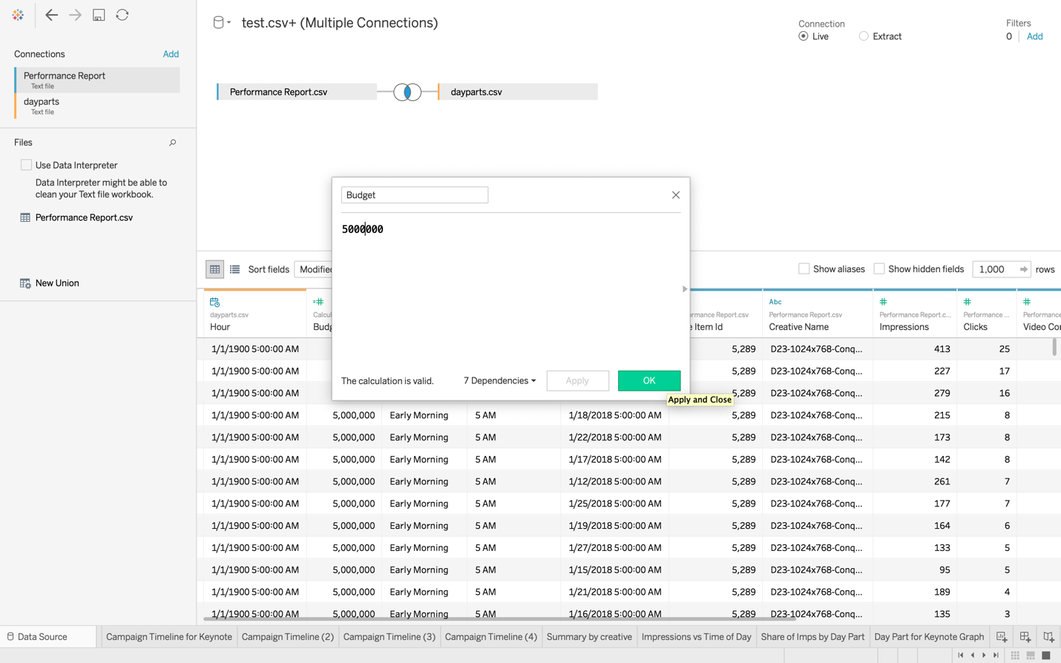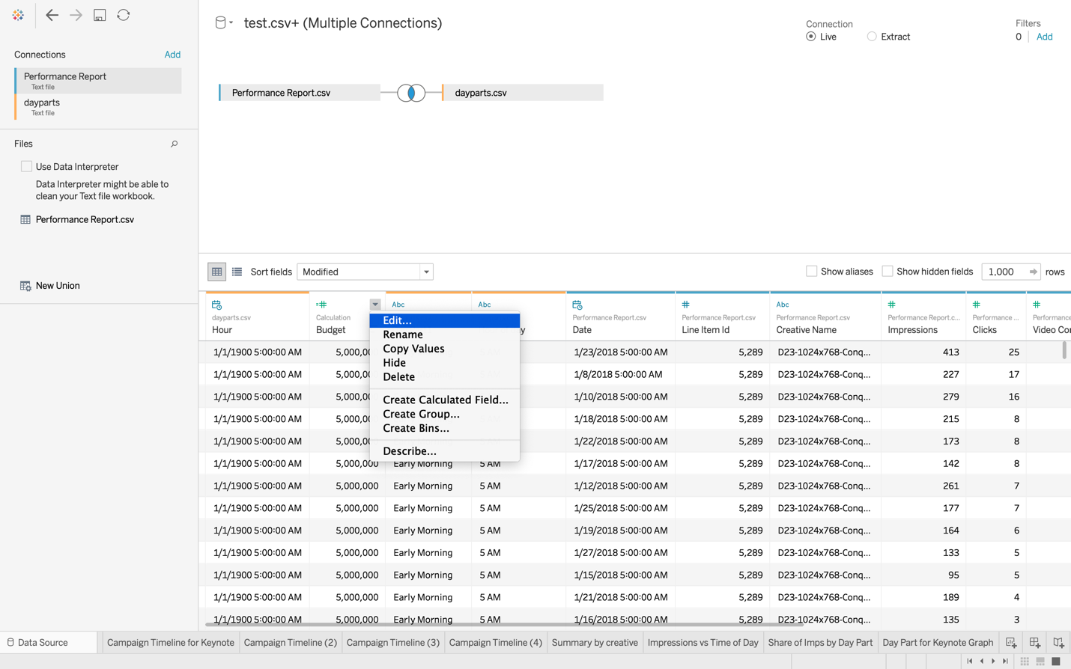

Do the same to update benchmark CTR and VCR if needed. Benchmark CTR is set to 0.56% and VCR to 72%. This may change depending on whether your campaign is a display campaign, or if it does not contain any desktop placements.

**Step 3: Navigate the workbook**

**/!\ Before pulling data from the workbook, make sure you updated the budget, the benchmark vcr and the benchmark ctr in the Data Source tab.**

**/!\ For worksheets 1 and 2, keep in mind that all of this data is already available on AdsDash+ AND we usually provide the client with the third party data for all of those metrics.**

**→ Worksheet 1: “Campaign Summary”**

Provides metrics over the whole campaign.

* Total Number of Impressions
* CTR (%)
* CTR (as a % of benchmark CTR)
* VCR (%)
* VCR (as a % of benchmark VCR)

These values are used to generate the summary slide in a Digital Campaign Performance Study.

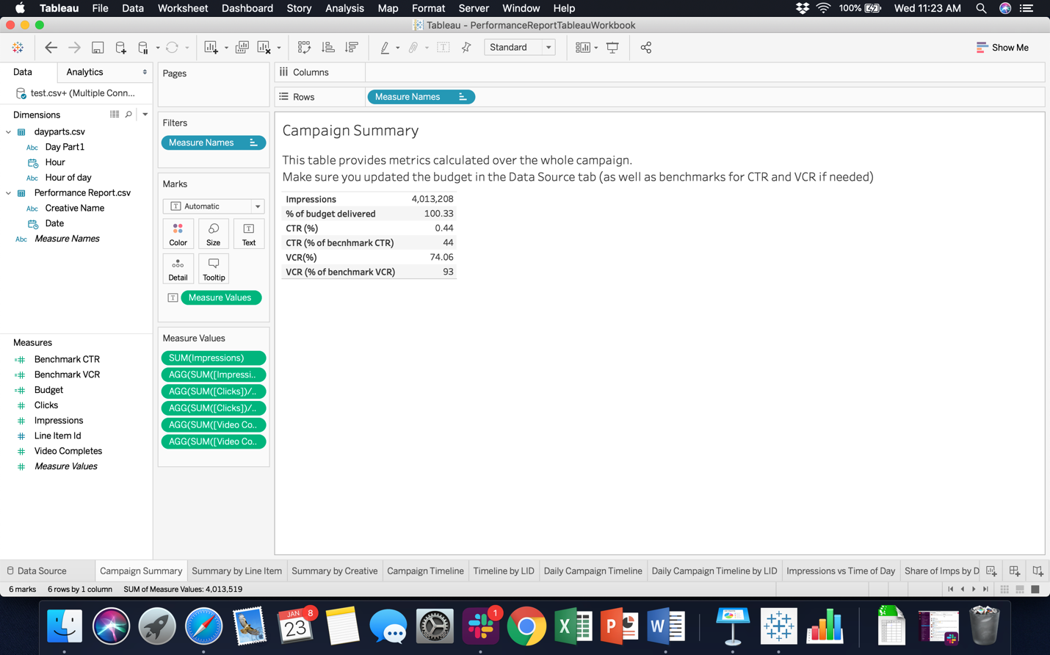

**→ Worksheet 2: “Summary by Line Item”**

Provides metrics (Impressions, CTR, VCR) broken down by Line Item or groups of line items.

You can use it to observe how different line items performed, and to generate the slide “Performance by Targeting Tactic” in a Digital Campaign Performance Study.

On the right pane of the worksheet, you can select which line items you want included in the table. For example if you want to calculate metrics for the “Conquering” targeting tactic, you would select all of the line items corresponding to this tactic and write down the corresponding metrics.

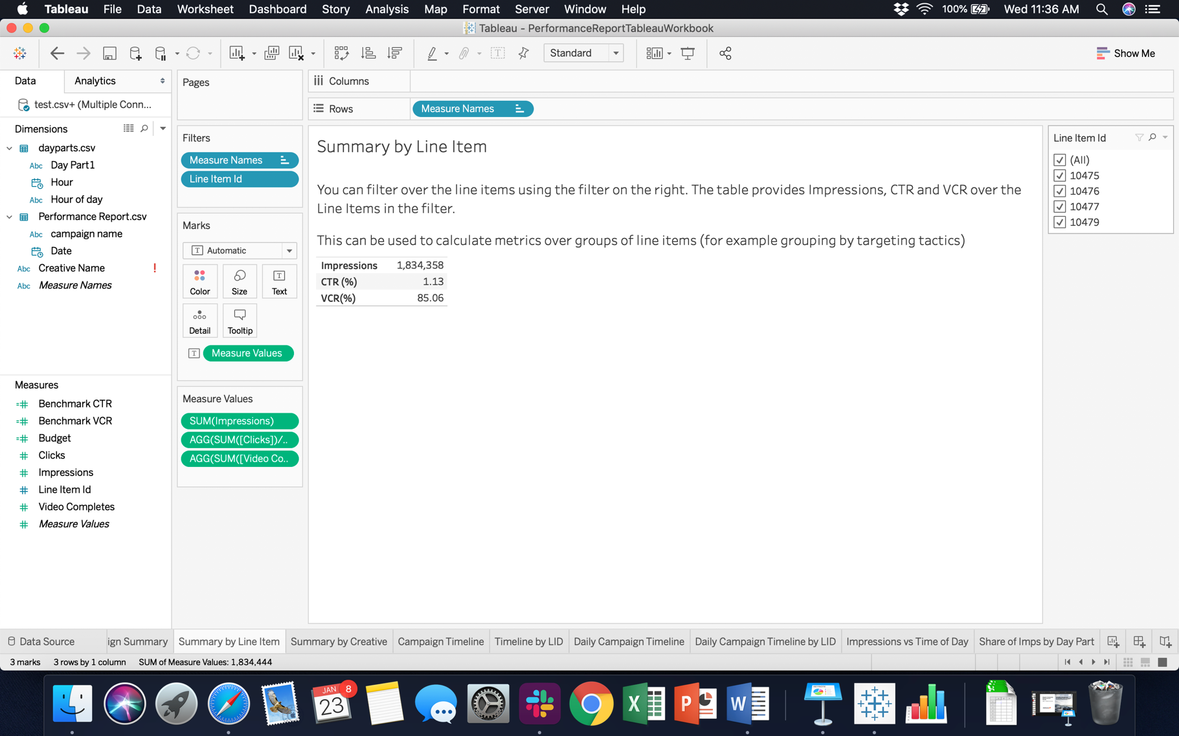

Filter by LID here

**→ Worksheet 3: “Summary by Creative”**

Provides metrics (Impressions, CTR, VCR) broken down by creative.

You can use it to observe how different line creatives performed, and to generate the slide “Performance Summary by Creative” in a Digital Campaign Performance Study.

**→ Worksheet 4: “Campaign Timeline”**

Plots the cumulative number of impressions (as % of budget delivered) over time.

The y axis is $\frac{Total Number of Impressions Delivered}{Budget}*100$.

Depending on the length of your campaign, you can adjust the X-axis by clicking on (+) and (-) in the columns line (to choose hour/day/month).

This graph can be used to generate the “Campaign Delivery Progress” slide in a report.

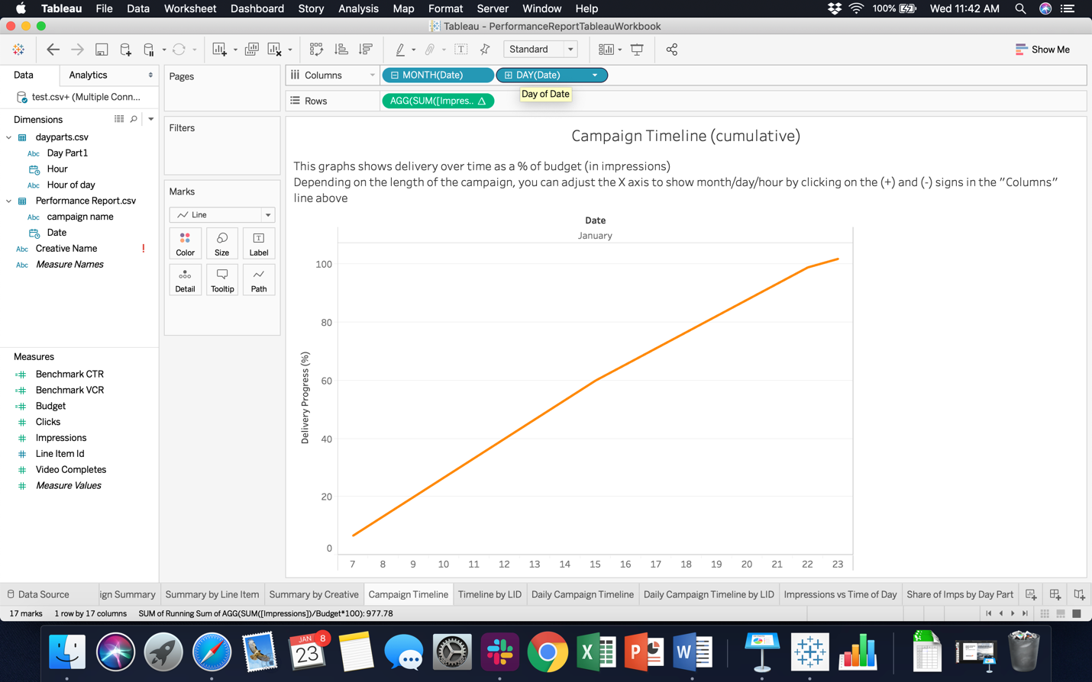



Adjust the X-axis here by clicking on (+) and (-)

You can copy the graph as an image by right clicking on it, then copy > image.

You can also copy the raw data by right clicking, then copy > data. You can then go to the Keynote presentation, click Edit Chart Data and paste your data.

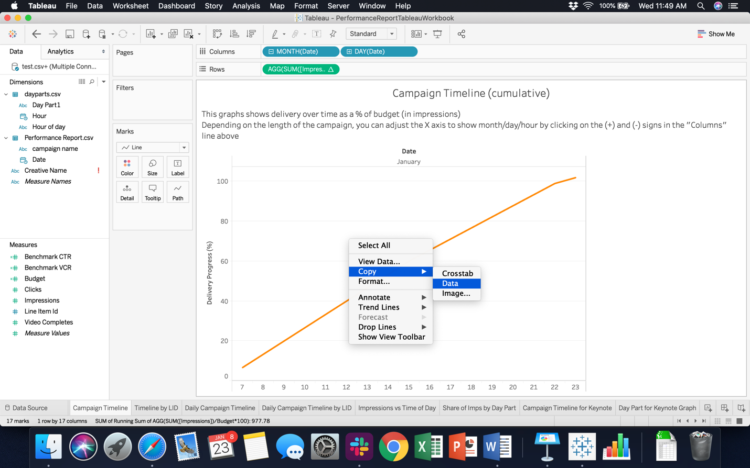

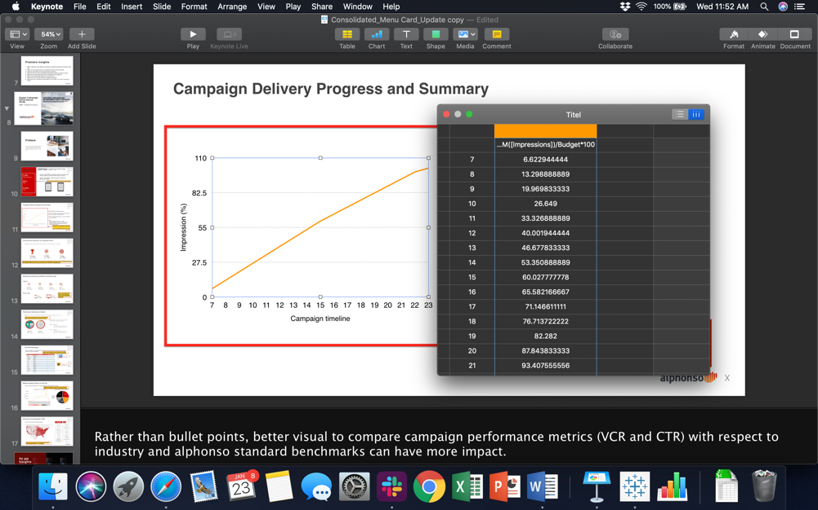

**→ Worksheet 5: “Campaign by LID”**

The graph here is the same as on the previous slide, but broken down into Line Items. You can filter the line items in in the right pane by selecting the ones you want to display.

**→ Worksheet 6: “Daily Campaign Timeline”**

The graph shows the number of impressions per day/month/hour (depending on how you adjust the X-axis).

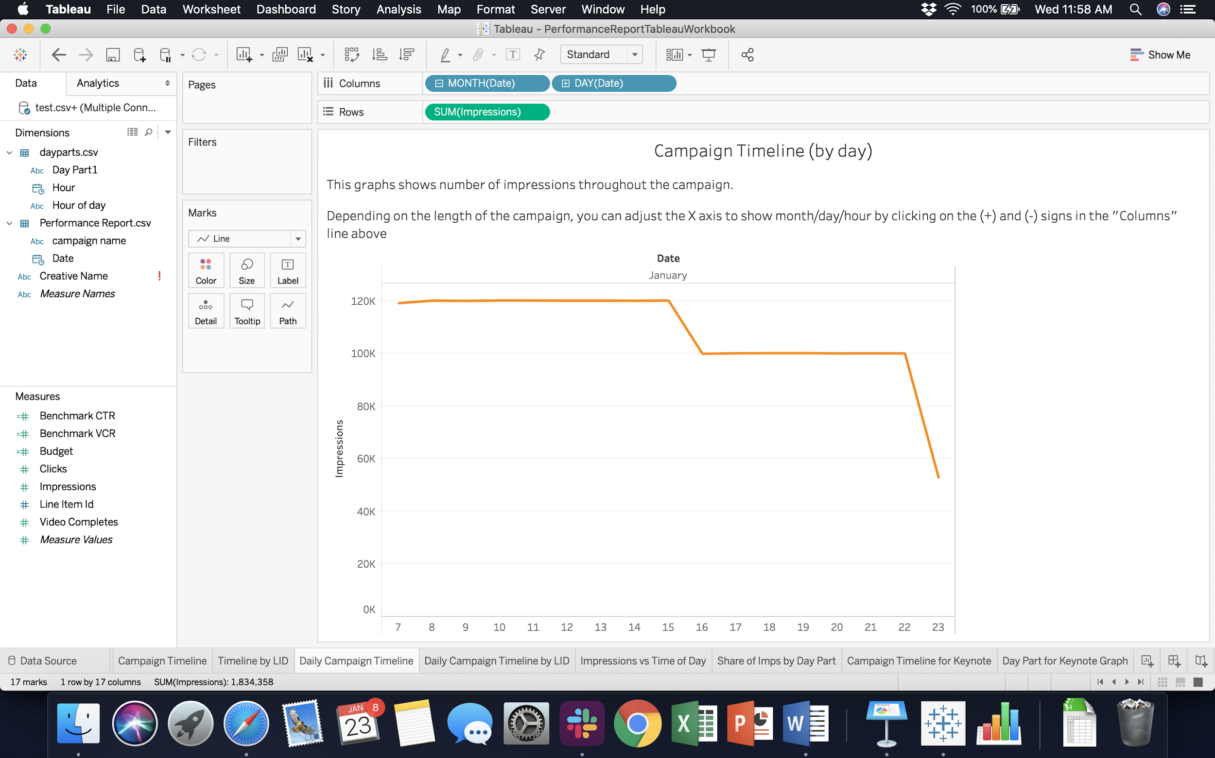

**→ Worksheet 7: “Daily Campaign Timeline by LID”**

Same as above but broken down by LID. You can filter the LIDs you want displayed and adjust the X axis.

**→ Worksheet 8: “Impressions vs Time of Day”**

This plots the average number of impressions as a function of the time of day. You can use this graph to generate the slide “Digital Campaign Delivery by Day Part” in a Digital Campaign Performance Study.

To copy the chart, either take a screenshot of it or copy the data (right click > copy > data) and paste it in the Keynote (edit chart data then paste). WARNING: you may have to rearrange the lines (i.e. order the hours) if you choose this option.

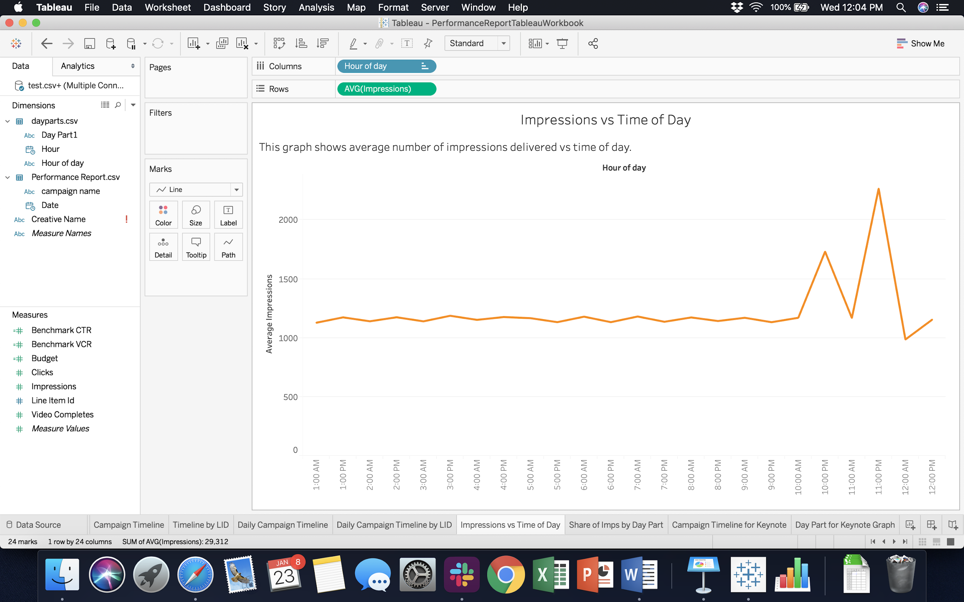

**→ Worksheet 9: “Share of Imps by Day Part”**

This pie chart specifies the breakdown of impressions by day parts. It can be used to generate the slide “Digital Campaign Delivery by Day Part” (by taking a screen shot)

**→ Worksheets 10 & 11: “Campaign Timeline for Keynote Graph Generation” and “Day Part for Keynote Graph Generation”.**

Both of those worksheet are tables you can copy to generate graphs on Keynote (instead of taking screen shots).

The first one can be copied to generate the “Campaign Delivery Progress” slide in a report.

The second one can be copied to generate the pie chart of impressions vs Day Part.

**2- Tableau Geography Report Workbook**

This workbook can be used to generate all of the maps required in a Digital Campaign Performance Study. It shows viewership and completion rate by city, DMA and state/region.

To generate the maps, you will need:

* Your campaign name or ID
* Access to Beeswax
* The Geography Report Workbook ([here](https://www.dropbox.com/home/Alphonso%20Campaign%20Reporting/Elle%20%26%20Gaelle?preview=Geo+Report+Workbook.twbx))

*Note: you may see that the workbook uses an additional spreadsheet entitled “dma”. This spreadsheet is used to map each dma to a latitude/longitude pair in order to show DMAs on a map.*

**Step 1: Generate a Geography report on Beeswax**

Log in to Beeswax ([here](https://alphonso.beeswax.com/login?u=%2Fadvertisers))

In the Reporting tab, go to the Query tool.

Fill in the following fields:

* Report type: Geography
* Fields:
  + Country
  + City
  + Metro/DMA
  + Metro/DMA code
  + Region/State
  + Other fields you wish to include

Metrics

* + Clicks
  + Impressions
  + Video Completes
  + Other metrics you wish to track
* Select your campaign in Campaign Name or Campaign ID field
* Format: CSV

Run and Download the report

**Step 2: Import your data to the workbook**

Get the Geography Report Tableau WorkBook [here](https://www.dropbox.com/home/Alphonso%20Campaign%20Reporting/Elle%20%26%20Gaelle?preview=Geo+Report+Workbook.twbx) and open it

Import your data using the steps in section 1 (in a few words: Data Source > Edit Connection)

**Step 3: Navigating the Workbook**

The workbook contains various maps showing number of impressions, CTR and completion rate over DMAs. The worksheets at the end of the book provide you with tables, sorted in decreasing number of impressions and completion rate. Those tables can help you generate campaign reports.

A few things to take into account when generating maps:

* Tableau does not have access to Longitude and Latitude for all of the cities, creating a map by cities will likely not contain every city in your campaign
* Every DMA is matched to a longitude/latitude/code and every city is matched to a DMA so DMA map is accurate.

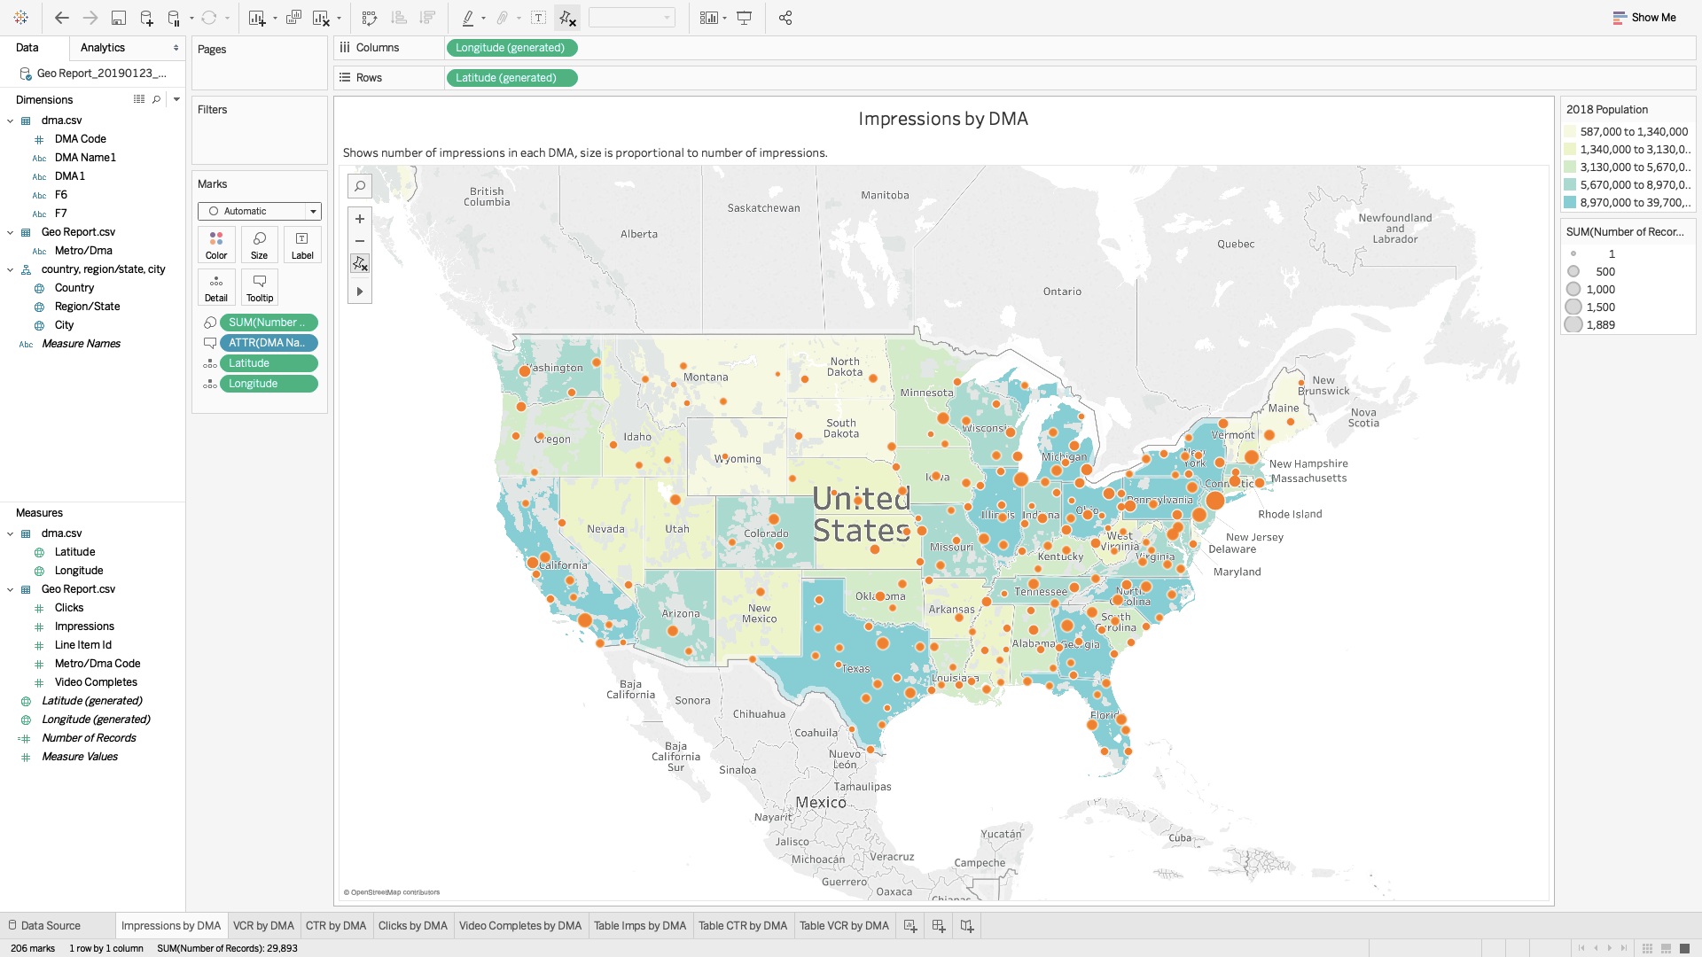

Geo Workbook Worksheet (maps and tables)

**3- Insights Report Workbook**

This workbook can be used to generate all of the graphs required in an Ad Insights Performance Study. It compares ad airings across a given time period for various brands and provides insights on airings by show, network, time of day and week. It can be used to provide a specific brand with insights on its airings over a time period, comparing it to major competitors.

To generate the graphics, you will need:

* The brand name
* The dates your study should cover
* Several major competitors of this brand (for comparison)
* Access to Alphonso Insights ([here](https://insights.alphonso.tv))
* The Insights Report Workbook ([here](https://www.dropbox.com/home/Alphonso%20Campaign%20Reporting/Elle%20%26%20Gaelle?preview=Insights+Report+WorkBook.twbx))

**Step 1: Generate an Insight report for your campaign**

Go to the Insights homepage ([here](https://insights.alphonso.tv))

Search for your brand (see screenshot)

Click on **Commercials**

Change the dates so they match your period of study

Add competitors in the **“Compare to”** section

Click on **Airings**, then on **Get Report** in the top right-hand corner.

Ask for an excel report and have it sent to your email address.

Download the report

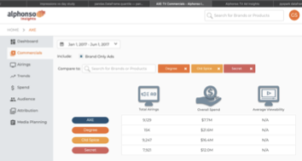

Figure 3 - Alphonso Insights Dashboard

**Step 2: Import your data to the workbook**

Get the Insights Tableau Workbook from [here](https://www.dropbox.com/home/Alphonso%20Campaign%20Reporting/Elle%20%26%20Gaelle?preview=Insights+Report+WorkBook.twbx)

Import your report to the workbook by following the steps indicated in Section 1 (Data Source > Edit Connection).

**Step 3: Navigate the Workbook**

This workbook consists of a set of worksheets designed to compare the brand of interest and its competitors, and a dashboard which allows to focus on each specific brand.

**→ Worksheet 1: Number of Airings**

This slide provides total number of airings over the specified time period across the different brands

**→ Worksheet 2: Airings by Product**

This slide provides number of airings by product over the specified time period. The products are colored by brand, and you can filter over the brands in the right pane (check or uncheck the boxes)

→ **Worksheets 3: Airings by Network**

These slides provide insights on airings by network by generating a stacked bar diagram showing total number of airings for the top 15 networks, colored by brand.

Copying the data from this worksheet will give you a table with 3 columns: brand, network and #airings, which can be used to generate graphs.

→ **Worksheets 4: Airings by Show**

These slides provide insights on airings by show by generating a stacked bar diagram showing total number of airings for the top 25 shows, colored by brand.

Copying the data from this worksheet will give you a table with 3 columns: show, network and #airings, which can be used to generate graphs.

**→ Worksheet 5: Airings by Pod Position**

This slide provides a stacked bar diagram showing, for the first 5 pod positions, how many ads were aired in total and by each brand.

**→ Worksheet 6: Brands by Pod Position**

This slide provides pie charts showing the proportion of each brand for opd positions 1 to 5. You can filter over brands in the right pane.

**→ Worksheet 7: Ad airings by week**

This slide provides stacked bar chart showing how many ads were aired by each brand over the weeks

**→ Worksheet 8: Airings vs Time of Day**

This slide provides a graph showing average ads aired each hour of the day, for every brand.

**→ Worksheet 9: Airings by Day Part**

This slide plots pie charts showing proportion of ads aired during each day part for each brand.

**→ Dashboard**

The dashboard is primarily used to filter by brand and consists of 6 different worksheets.

In the upper left worksheet, entitled Total Airings, select the brand you wish to focus on by clicking on the corresponding slice in the pie chart (see screenshot).

Once you have selected your brand, the other graphs will automatically adapt and show graphs corresponding to this brand only.

You will be able to see, for the brand you selected:

* Fraction of airings in each of the top 5 pod positions
* Fraction of airings in each day part
* Top 10 networks for this brand and the corresponding number or airings
* Top 15 shows for this brand and the corresponding number of airings
* Airings by week for this particular brand

**4 - FAQ**